SQL
Mini Project-3
1.Create a MySQL table called playlists to store Spotify-style music playlists, with columns: playlist_id (primary key), user_id (foreign key), name (varchar), and created_at (datetime). Write the CREATE TABLE statement.
CREATE DATABASE spotify_db;
CREATE TABLE playlists ( playlist_id INT PRIMARY KEY,
user_id INT,
name VARCHAR(100),
created_at DATETIME );
Output-
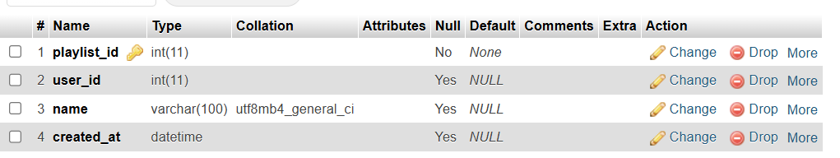

2.Insert three sample records into the playlists table: one for a user with a 'Workout Mix', one with a 'Chill Vibes', and one with a 'Top Hits' playlist. Use realistic data for each field.
INSERT INTO playlists (playlist_id, user_id, name, created_at)
VALUES
(1, 101, 'Workout Mix', '2026-10-01 08:30:00'),
(2, 102, 'Chill Vibes', '2026-10-03 19:00:00'),
(3, 101, 'Top Hits', '2026-10-05 21:15:00');
Output-
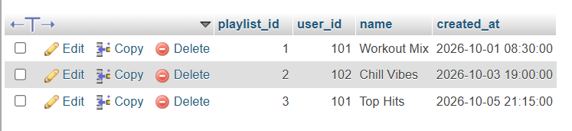

3.Write an SQL UPDATE statement to rename the 'Chill Vibes' playlist to 'Evening Chill' for a specific user_id.
UPDATE playlists
SET name = 'Evening Chill'
WHERE name = 'Chill Vibes'
AND user_id = 102;
Output-
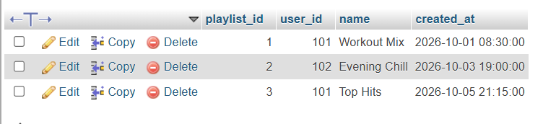

4.Write a DELETE statement to remove a playlist named 'Workout Mix' for a given user_id from the playlists table.Make sure your WHERE clause targets only the intended row.
DELETE FROM playlists
WHERE name = 'Workout Mix'
AND user_id = 101;
Output-
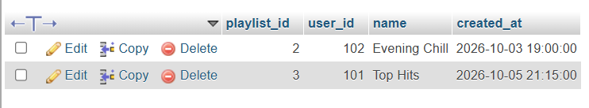

5.Create a stored procedure named GetMonthlyPlaylistCount that takes a user_id and a month (as an integer) as input, and returns the total number of playlists the user created in that month. Use the MONTH() function in your WHERE clause.
DELIMITER //

CREATE PROCEDURE GetMonthlyPlaylistCount(
IN p_user_id INT,
IN p_month INT
)
BEGIN
SELECT COUNT(*) AS total_playlists
FROM playlists
WHERE user_id = p_user_id
AND MONTH(created_at) = p_month;
END //

DELIMITER ;

CALL GetMonthlyPlaylistCount(101, 10);
Output-
